**Botafy Platform & Botpage Review:**

1. When we open an app, the input search field icons are irregular. Mainly the send icon and the plus icon. Both are not the same icons, I used in my prototype. Attaching the screen shot below:



1. When the app is giving a pic, the corner radius are sharp and also , its filling the complete screen. In the prototype it’s done covering only 2/3rd of the screen. Please make the corners smooth as it’s done in the prototype.

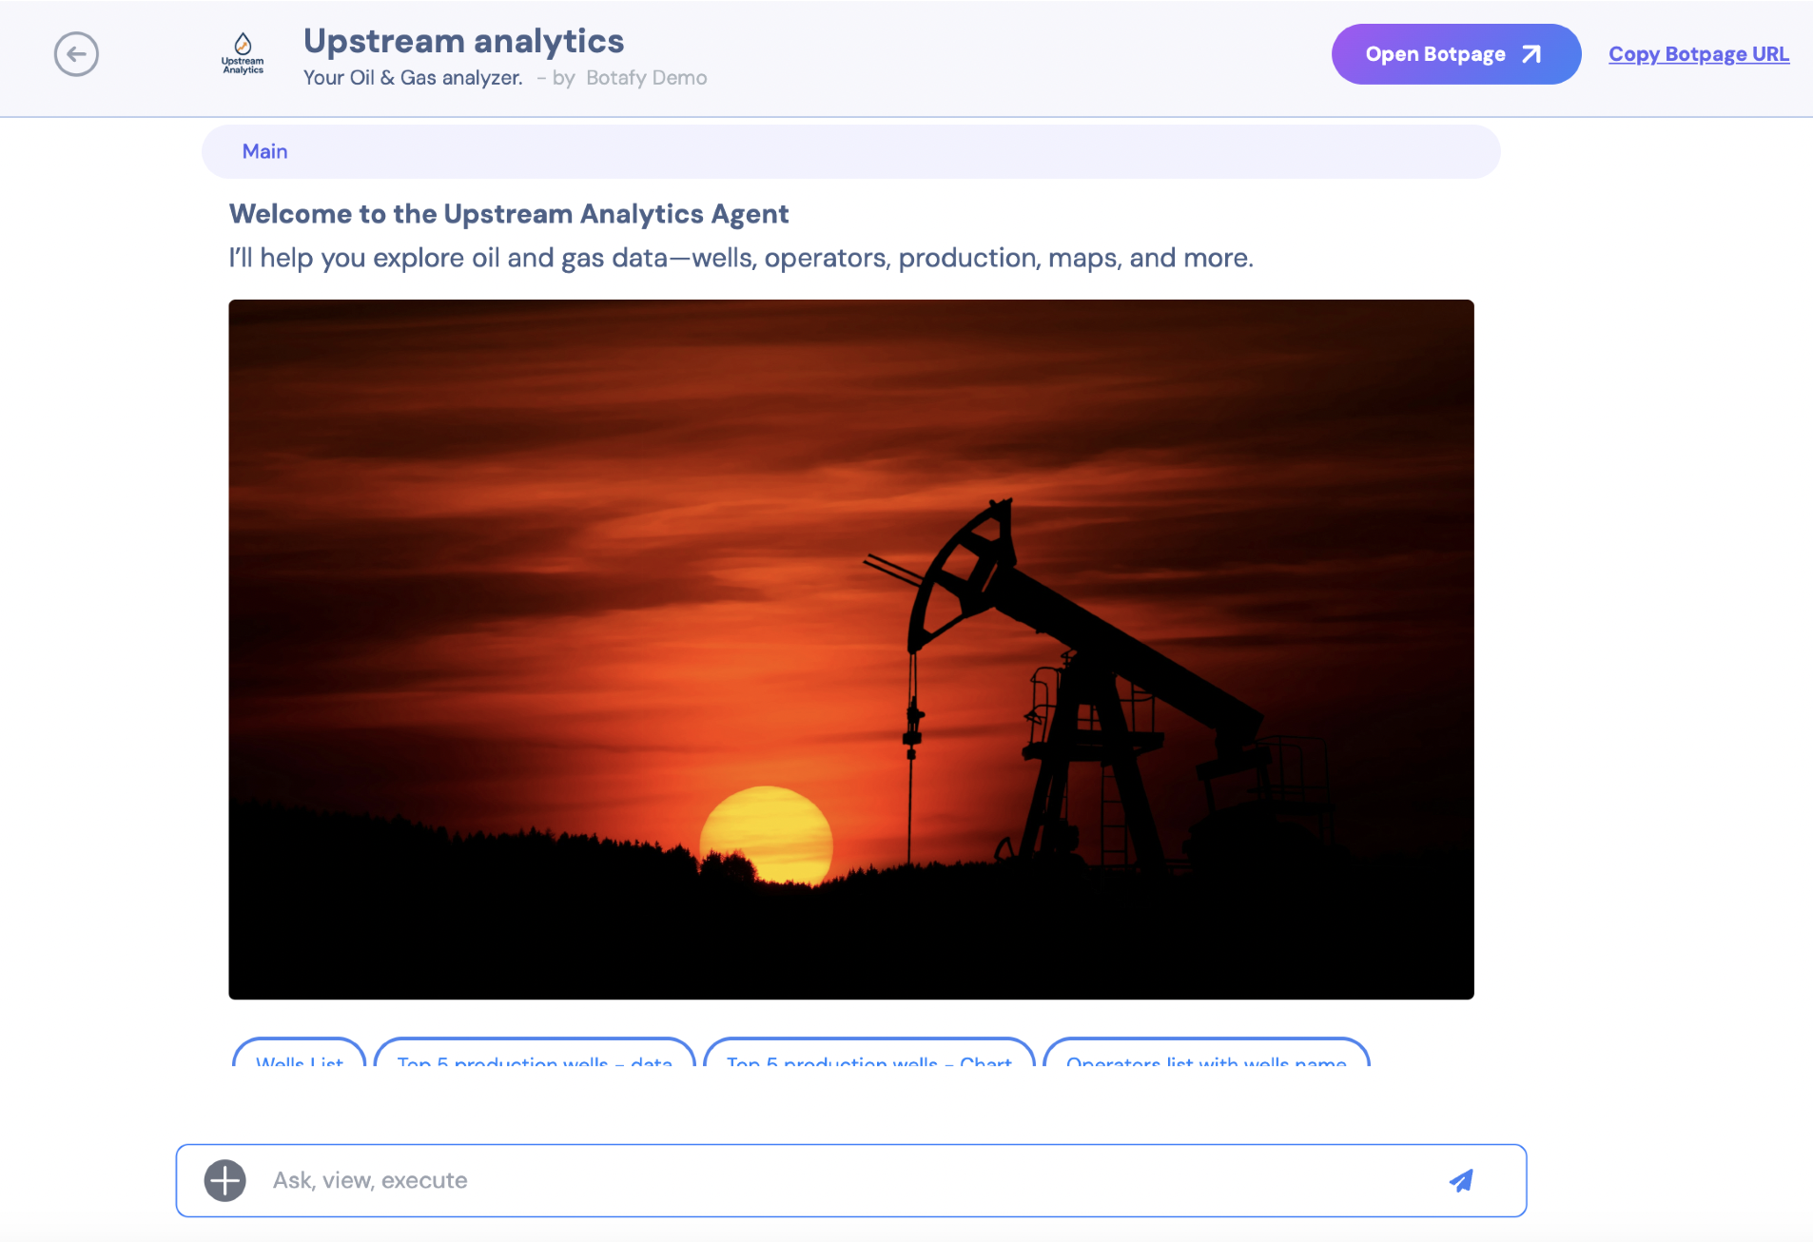

1. Also when the pic is hovered the download button must appear. This feature is missing in the current production. I can see the download button, only after opening the image to fullscreen view.
2. I tried to get 3 to 4 images at a time to get an idea upon how the carousel feature works. But, it seems like, the app can provide 3 to 4 pics at a time, but images are not previewing properly and not shown in carousel format. Attaching the screenshot below.

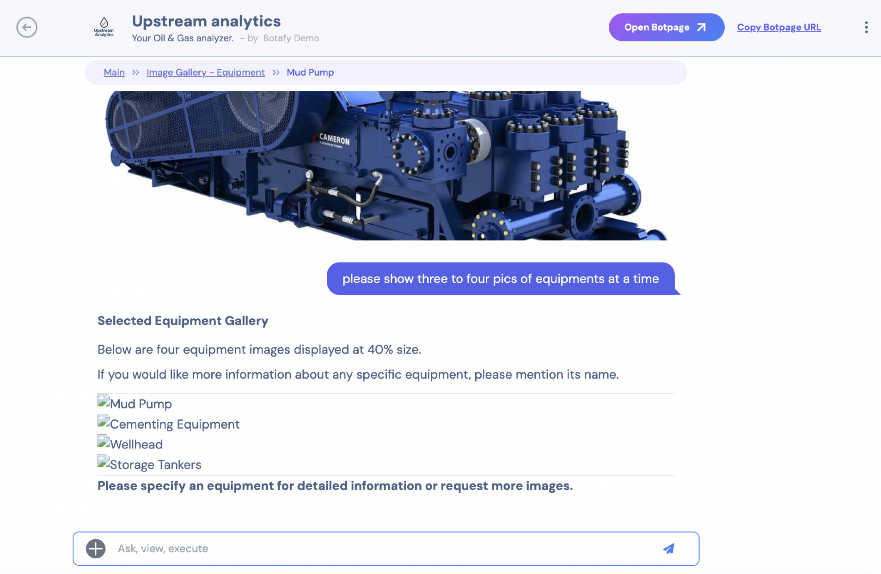

1. When the filecenter is opened, and closed from side panel, the input field is showing the animation of “Generating Response”. I think it’s a glitch. Please check this one.
2. When the file center is opened, the check box icon is not proper, like how it’s there in the prototype.

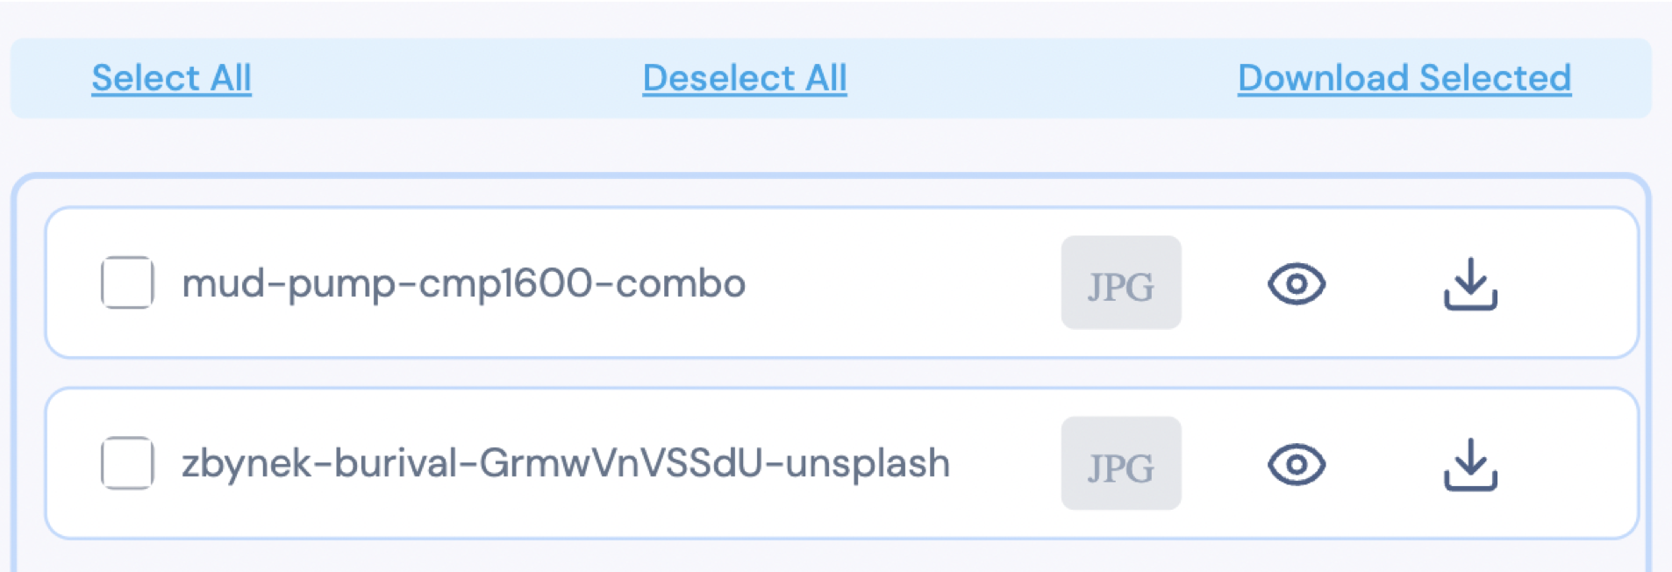

1. The file flags given are not appearing in the same font, like the prototype. (DOC, JPG, PNG). Attaching the screenshot below:

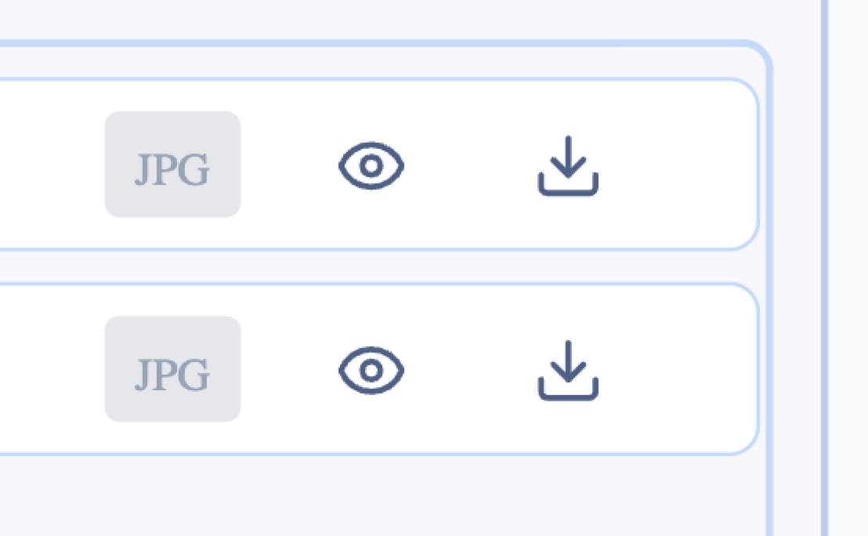

1. For Document the file flag will be DOC. Don’t use DOCX as it's a four letter word and its not consistent with the space consumption. Looking awkward.

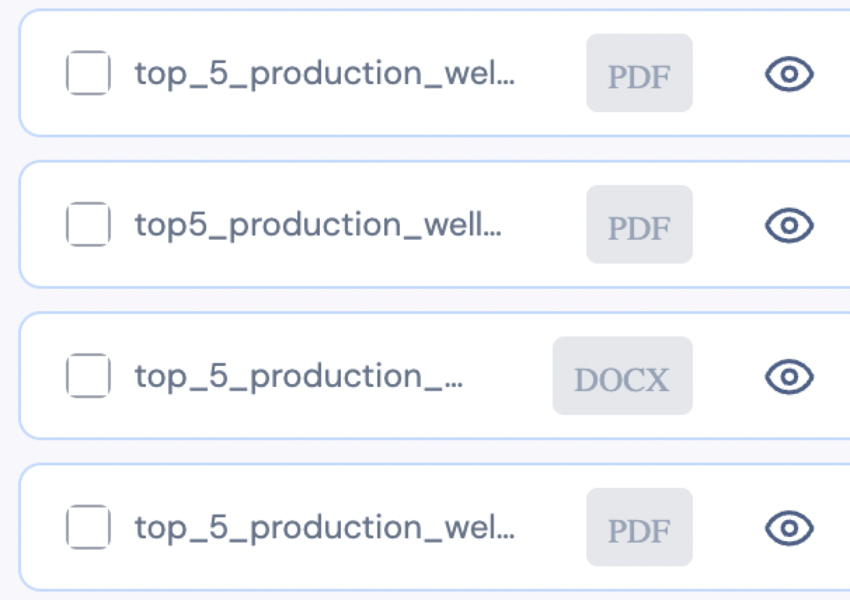

1. When the file center is opened, the main chat interaction becomes cluttered with nav head. Attaching the screen shot below:

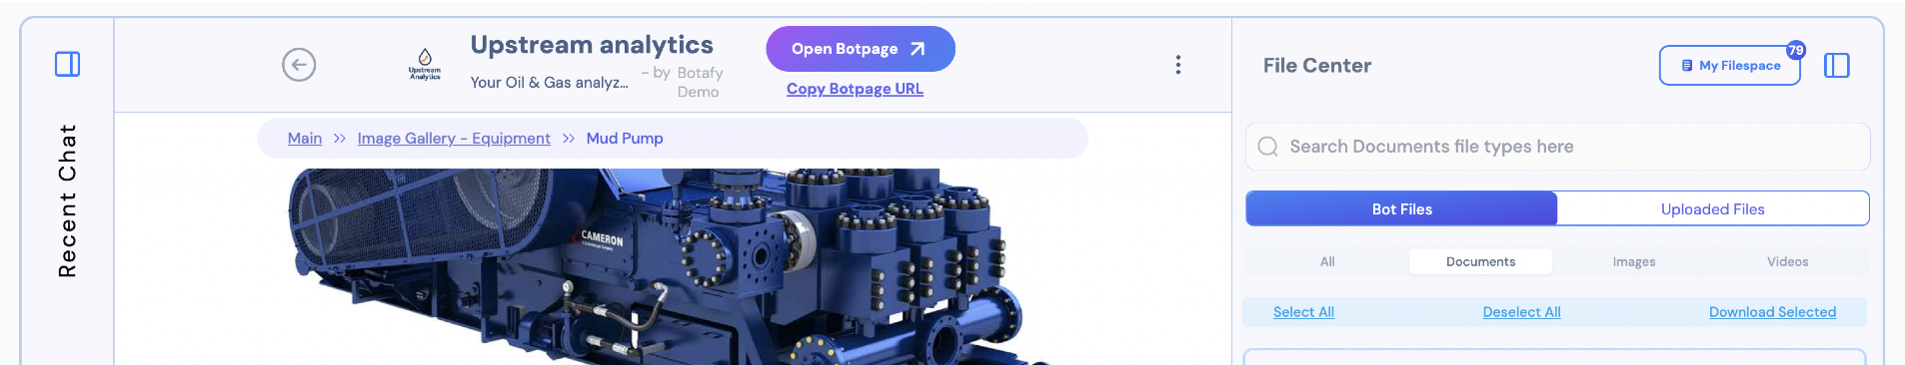

1. The filespace is having a search bar in it. The text inside the search bar is bold, which is unnecessary .

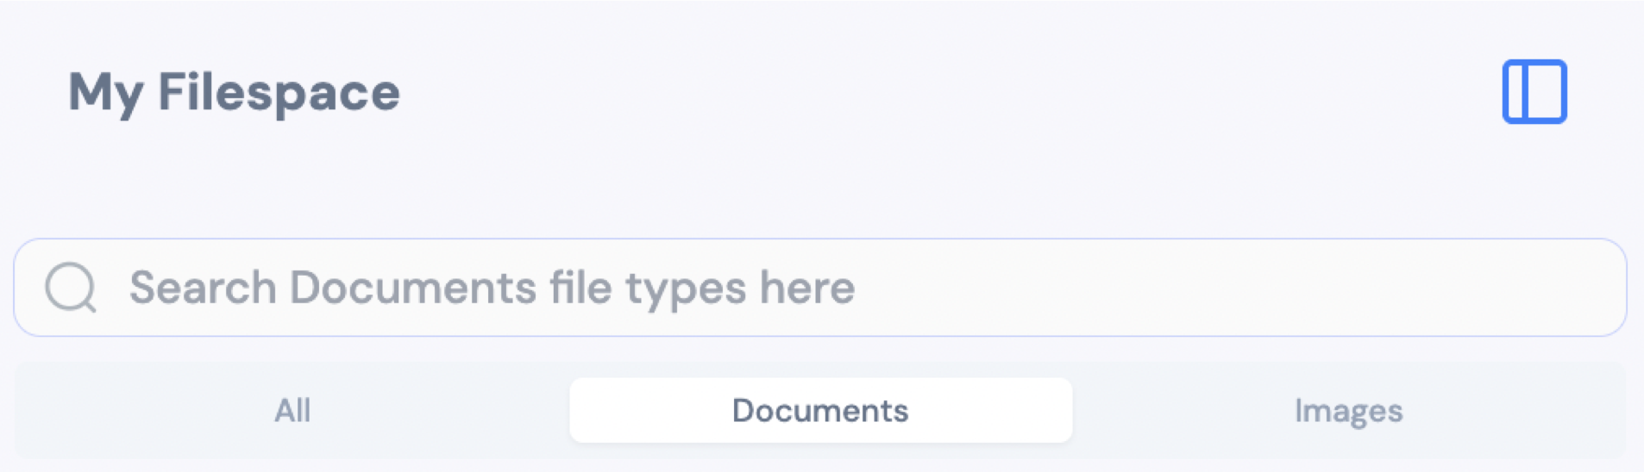

1. Inside the upstream analytics bot page - the “AI powered by” text below the input field is not as per the prototype shared. Attaching the screenshot below:

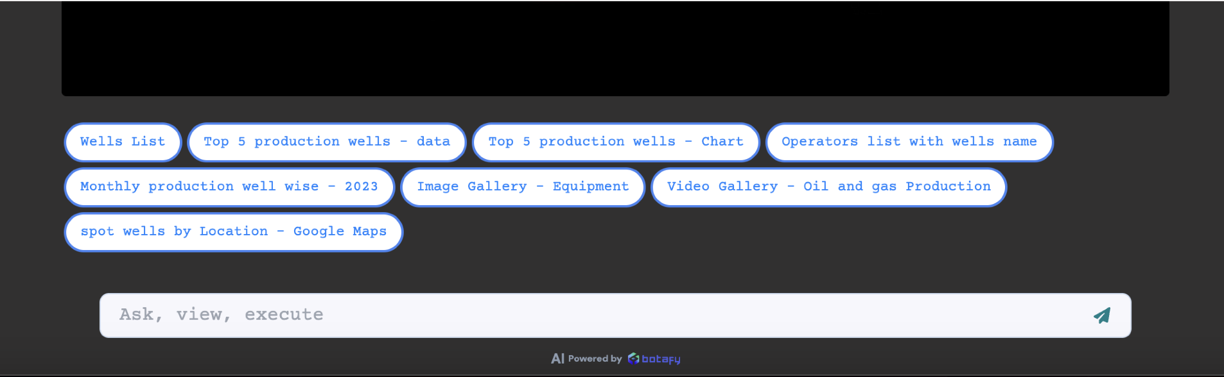

1. In Upstream Analytics BotPage, when I clicked “Download PDF” it prompted that it had provided a link. But I am not able to see any link or a downloadable file as well. Attaching the screen shot below:

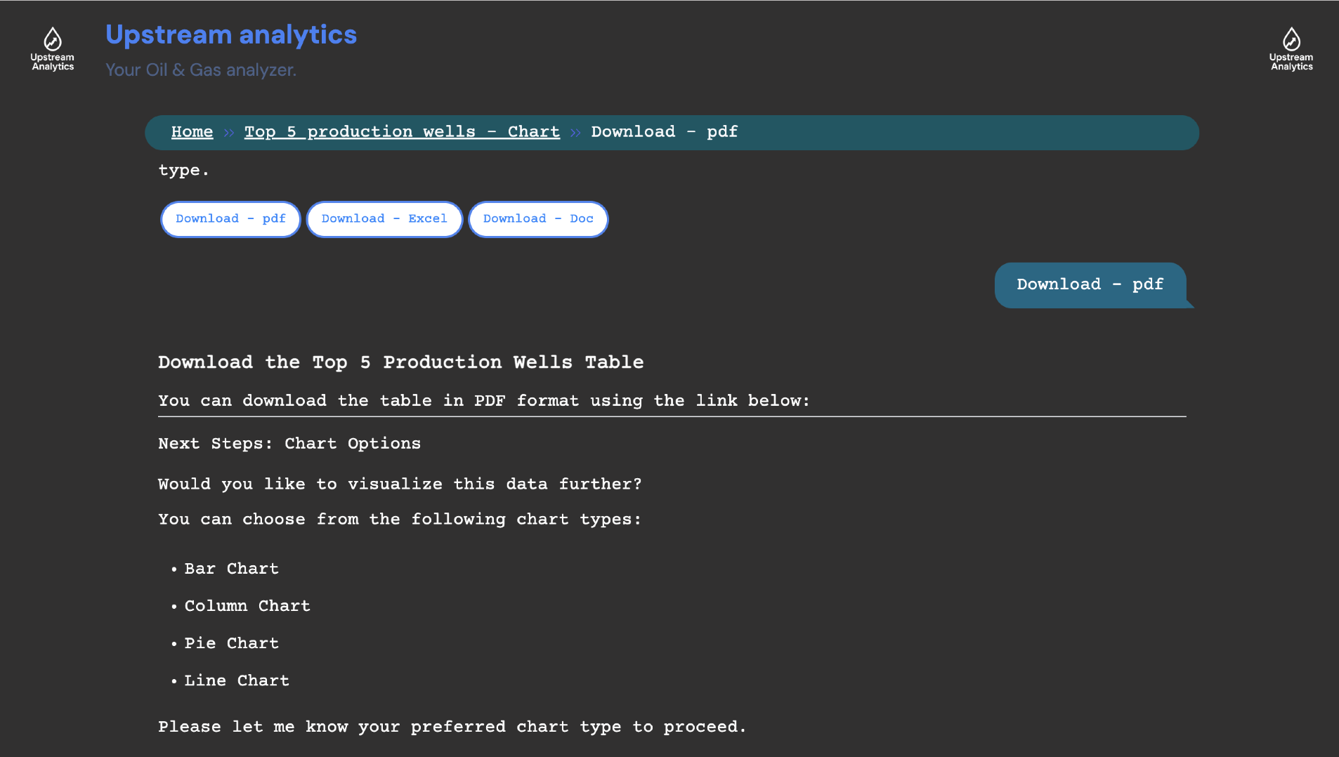

1. It asked for chart options without me requesting it. Also the chart options are not provided in tags format. I manually typed barchart as input. But app is frozen after that.

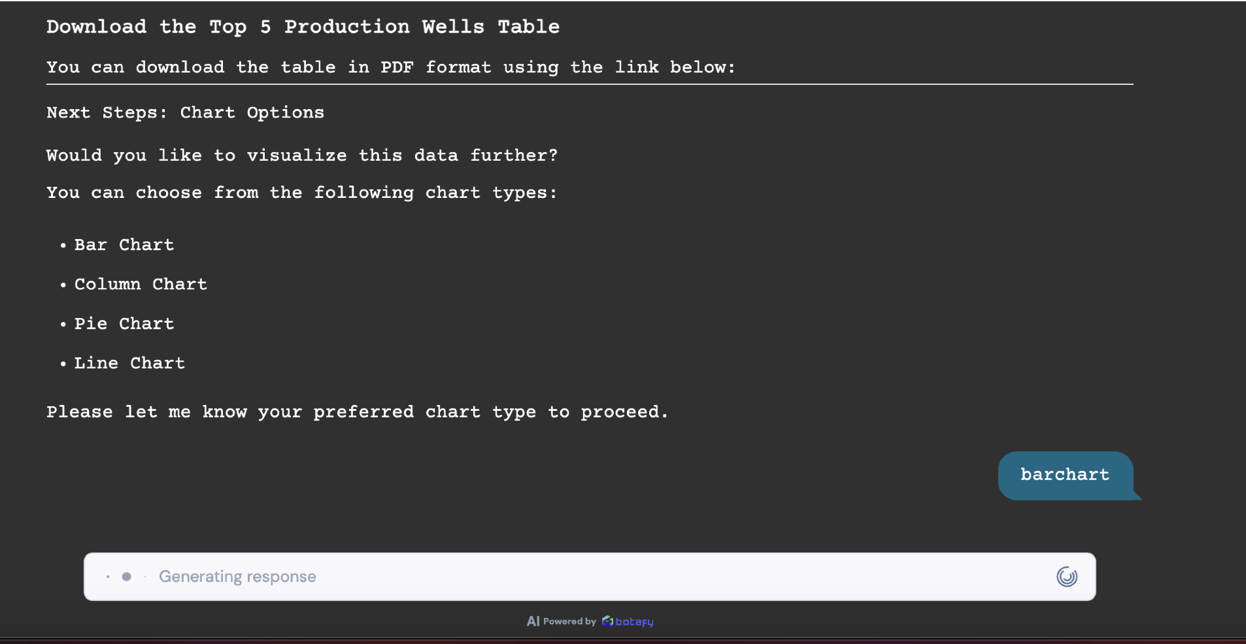

1. In edit botpage details of Upstream Analytics, the avatar and brand logo placeholders are empty and not previewing anything. Attaching the screenshot below:

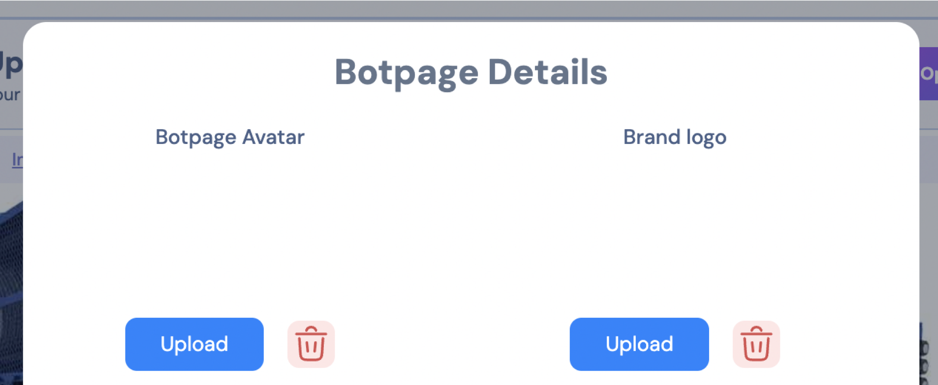

1. In edit botpage details, the input field font color is not pure black. It’s having a different color code. Please refer prototype. Attaching the screenshot below:

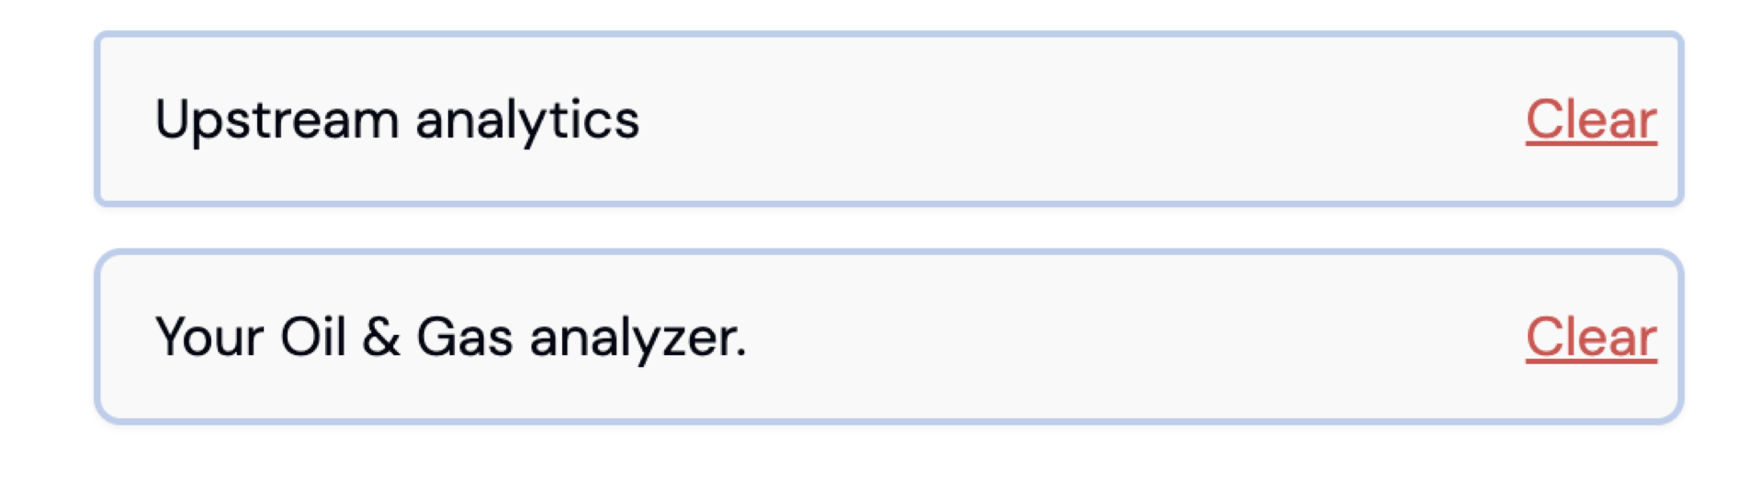

1. In the bot page details color settings options have different font in prototype. Please change it to what the prototype is having.

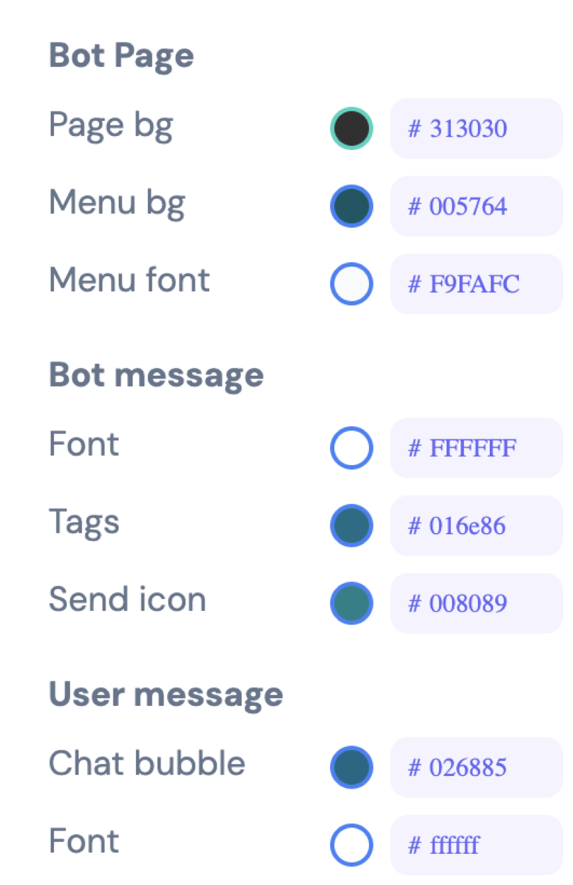

1. The color wheel options like RGB, HEX, HSL also are not having the same font that is there in the prototype.

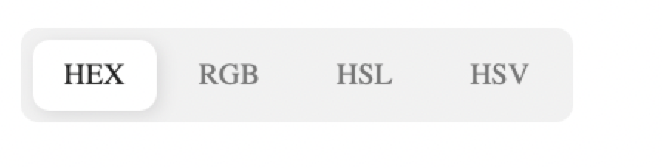

1. In Bot page font - the accordions must be facing downwards before expanding. But its looking upwards in the production. Please change this.

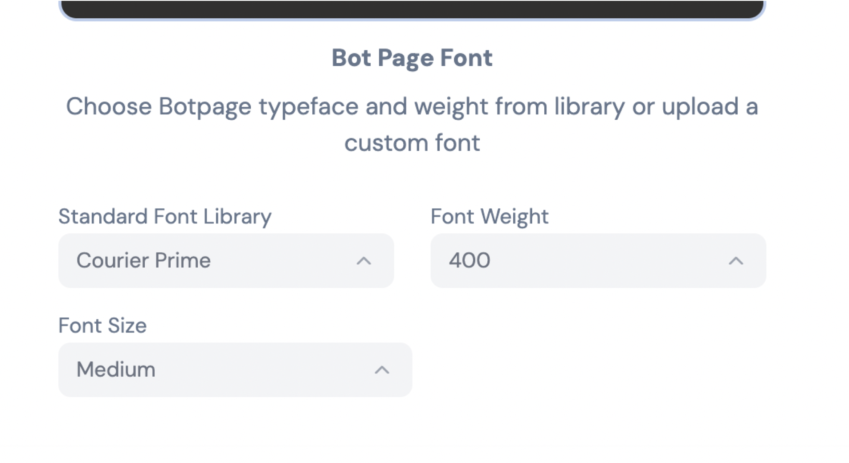

1. The slider in the edit botpage can be placed at the bottom of the hex code. Now in production, the slider is in the top and hex code and opacity input field are in the bottom. They are not having any link or proximity.

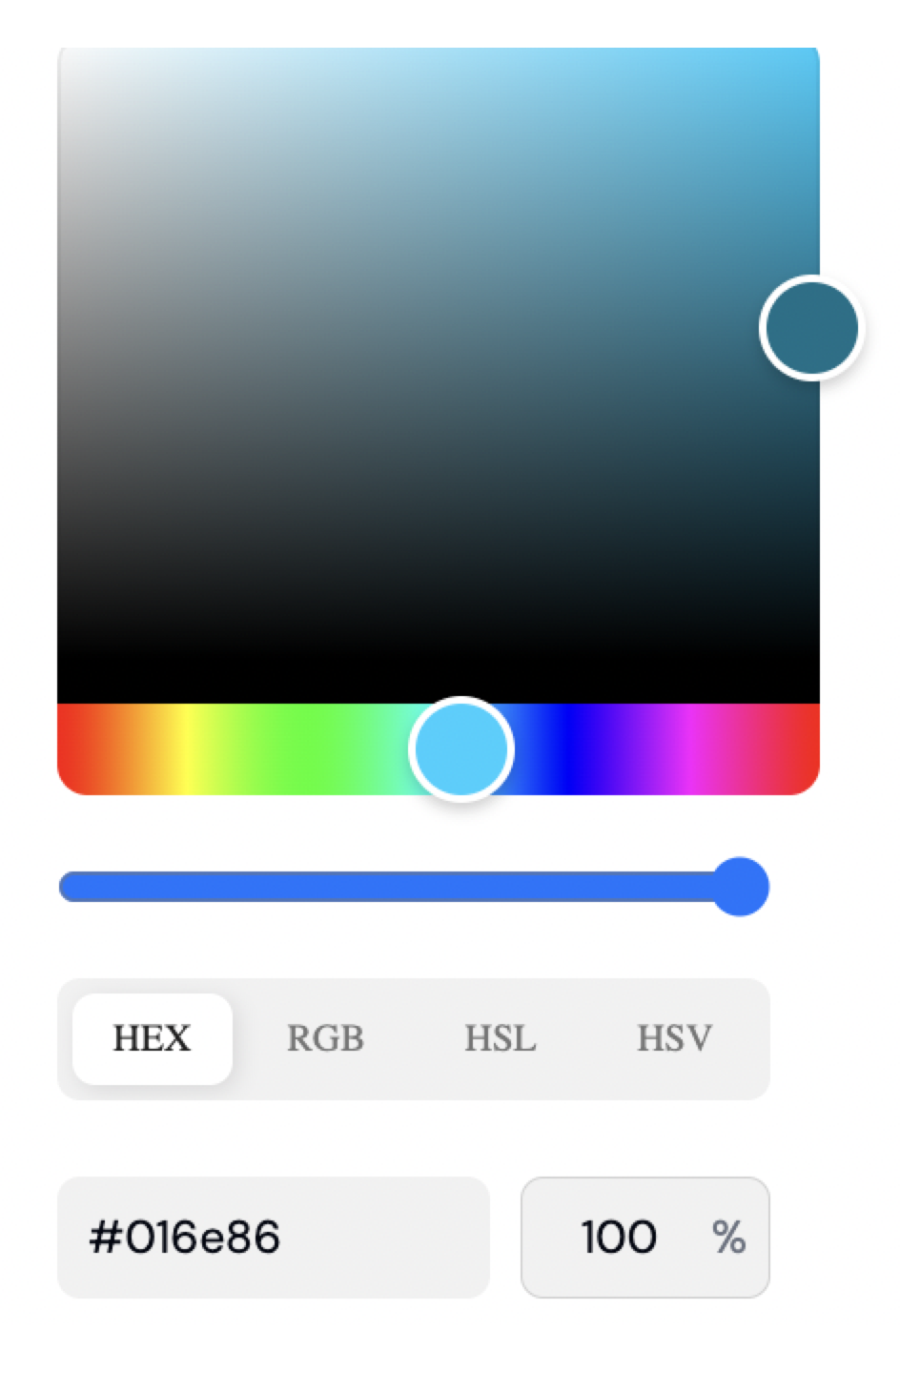

1. In EQA sales playbook app, when a particular tag is selected, the response from the bot is completely in extrabold. This is not needed. We can follow hierarchy like the following:  
   Title - Bold  
   Paragraph heading - Semibold / Medium  
   Paragraph - Regular  
   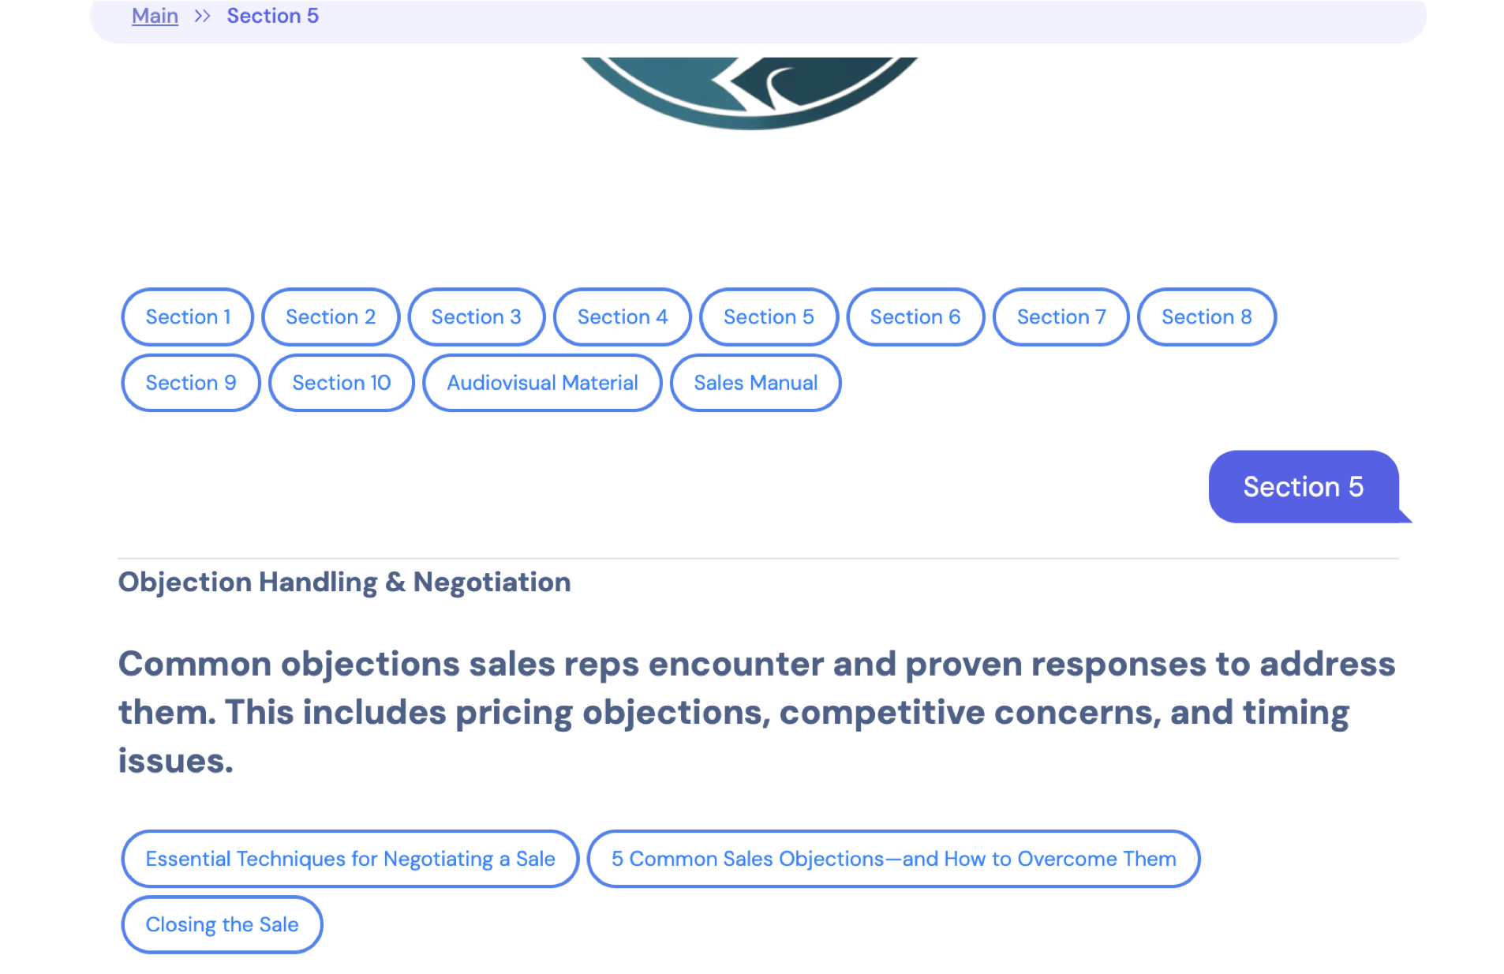
2. Opacity slider is not working. I was trying to reduce the opacity of a particular color. Accessing slider has no effect on the preview window.

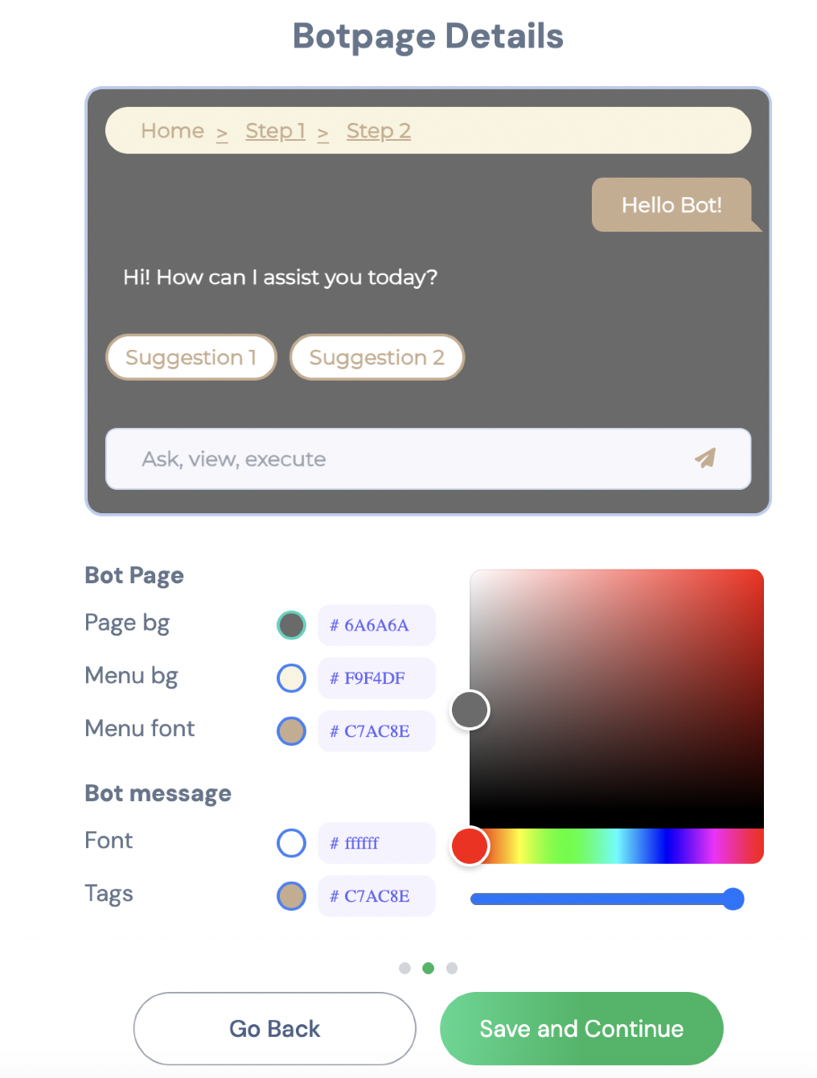

1. I tried creating Renewal Method Botpage. Faced issue with font color for suggestion. Also having a stroke around it of different color.

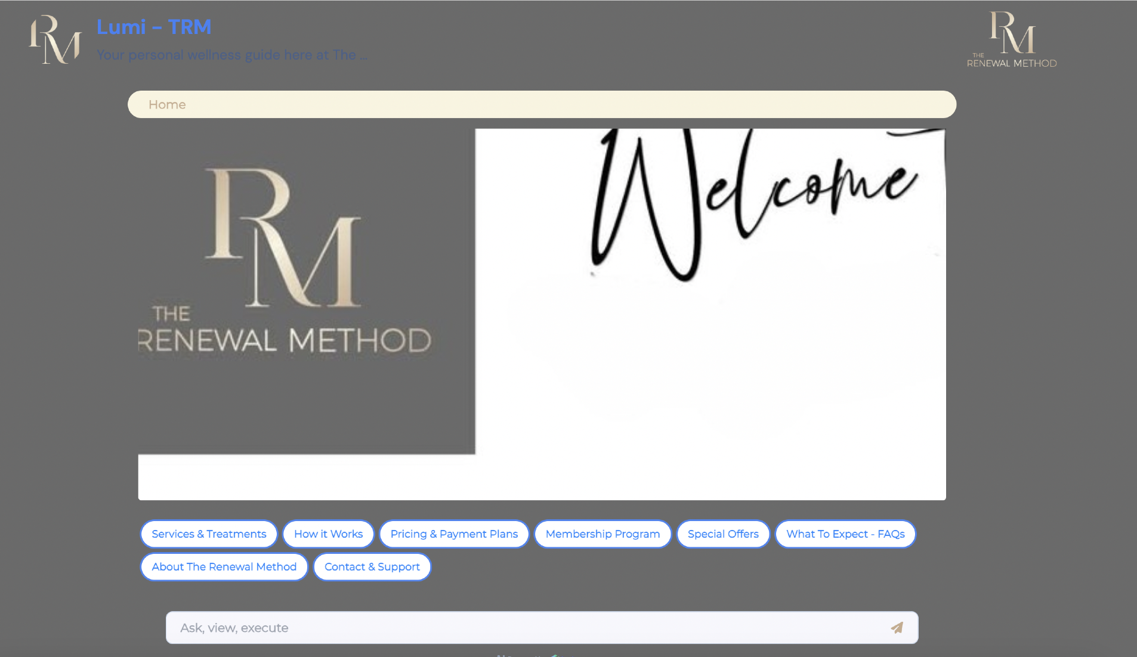

1. When I opened Common Desk Bot, suggestions appear two times, one above the image, and one below the image. Attaching the screenshot below:

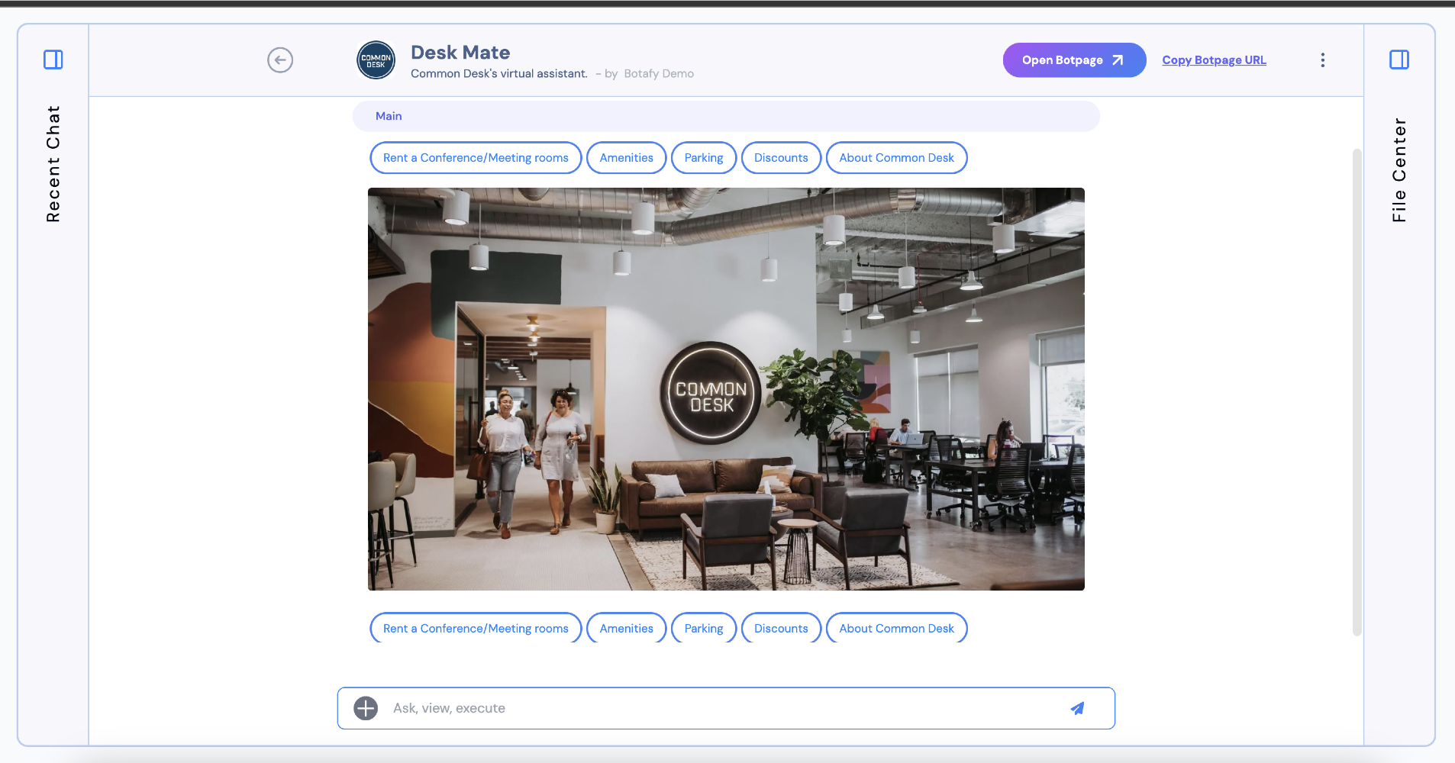

1. When particular suggestion is selected, multiple child suggestions are coming up. But those are appearing like pointers (unordered list). It should be shown like suggestion format. Because, now its expecting the user to type the suggestion. Attaching the screenshot below:

